1) Estimate Harm Caused by Existing Operations; (e.g. tonnes of CO₂)
First quantify the harm linked to burning fossil fuel as an energy source. Begin by collecting current fossil fuel usage (last year’s utility bills for natural gas and electric)
Information needed for “Ball Park” Estimating:
Organization Name:
Organization Address:
Description of Current “Energy System”
Source of Electrical Power (e.g. Xcel Energy, existing rooftop solar,. )

Source of Thermal Energy (for space heating, DHW)

Annual electric usage (12 months) 72040 kWh; (1.1) | Cost $ 12795
Annual natural gas usage (12 months) 5196 Therms; (1.2) | Cost $ 3830

 |  | YOUR INFO | EXAMPLE
 |  | Your Organization | First Universalist Church Denver
(1) | Quantify the current harm linked to burning fossil fuel (GHG Emissions)
(1.1) | What is your annual electric usage (kWh) |  | 72,040 kWh
(1.2) | Quantify the Harm caused by buying fossil fuel generated electrical power (metric tonnes of GHG)  Refer to Excel Worksheet”Externalities” tab –  a) Insert (1.1) into cell C29.  b) See Answer in cell C31, put in (1.2) |  | 50 metric tonnes
(1.3) | What is your annual natural gas usage (therms) |  | 5196 therms
(1.4) | Quantify the Harm caused by burning natural gas (metric tonnes of GHG)  Refer to Excel Worksheet”Externalities” tab–  a)insert (1.2) into cell B86.  b) See Answer in B95, put into (1.4) |  | 53 metric tonnes
(1.5) | TOTAL HARM  Sum of (1.1) and (1.3) |  | 103 metric tonnes / year
Use this information to illustrate visually the amount of harm currently caused by your fossil fuel system.

How Big is ONE metric ton (2200 lbs) of CO₂?
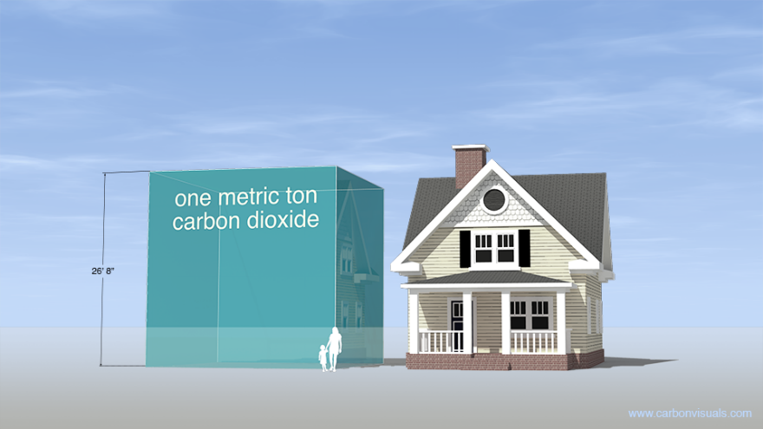

A metric tonne is 1000 kg = 2205 lbs = 2.2 tons.
At standard (sea level) pressure and 15 °C (59 °F) the density of carbon dioxide gas is 1.87 kg/m³ (0.1167 lb/ft³). One metric ton (2,205 lb) of carbon dioxide gas occupies 534.8 m³ (18, 885 ft³, 117,631 US gallons).

It would fill a cube 8.12 meters high (26’ 8” or 28’ 5” adjusted for 5,280’ altitude (14.7/12.15 psi)) or a sphere 10.07 meters across (33’ or 40’ adjusted for 5,280’ altitude). See the house size cube in the graphic. Ref: http://www.carbonvisuals.com/projects/usa-specific-image-set

Can you picture 103 of these containers stacked up the parking lot at the end of each year?
How do we properly/sustainably capture, sequester and dispose of this combustion waste?

FIRST UNIVERSALIST EXAMPLE
A graphic was constructed simply as a reminder to operate the First Universalist facility, GHG emissions were being dumped into the atmosphere by Xcel Energy (to generate electrical power) and by First Universalist (by burning natural gas to heat the facility and domestic hot water). When First Universalist did their homework and quantified their GHG emissions, they found that they were generating almost 2 metric tonnes of CO_{2 eq} EVERY WEEK.
Quantifying the 20-year Harm Caused by Burning Ancient Hydrocarbons
- Electric Power Generation: 1,073 tonnes CO_{2 eq}
- Heating: 1,173 tonnes CO_{2 eq}
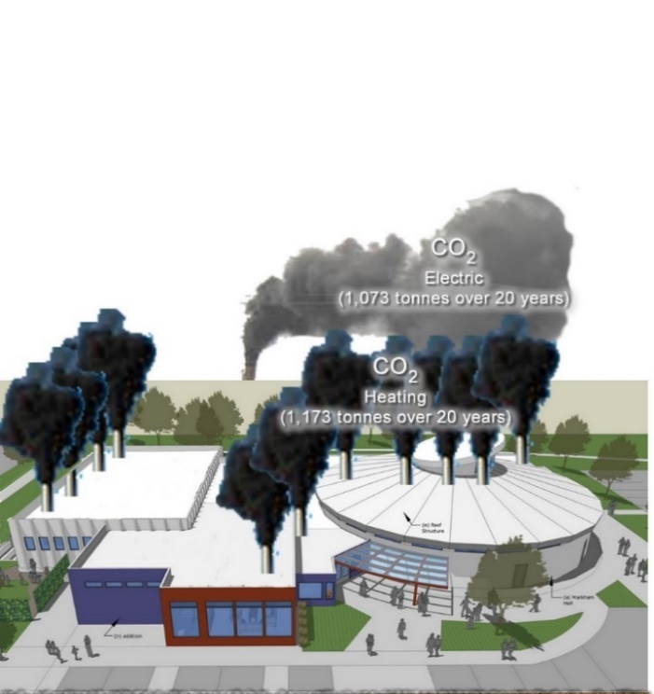  First Universalist  Weekly Fossil Fuel burning waste (CO₂)  TO SCALE  Weekly Trash Pickup  If we could see what we were doing  CO2 for  Electric  CO2 Natural Gas  These GHG Emissions are doing Harm | If the church “bagged” their CO₂ waste and set it out for weekly trash pickup for proper disposal, the graphic illustrates the amount of waste the trash company would have to haul away and then properly dispose of so it would not contribute to further global warming. Yes, the weekly trash is to scale with the building.
Even if First Universalist had “bagged” their weekly trash, it is not clear how or where the City & County of Denver would properly dispose of this waste. At the end of the years (52 weeks) there would be over 100 of these “bags” stacked up in the parking lot.

We now know that releasing this waste into the atmosphere is a crime against humanity because of the global consequences.

