# 3) Estimate Size of Solar System Required;

To get started, all you need is knowledge of your current annual electric bill (This does not include the cost of natural gas that is generally on the same monthly statement). You may already know how much electrical power you used over the course of a year. If you did not retain these monthly records, your utility company will send out the information upon request.

If you know your annual electric bill (i.e. the sum of the last 12 months electric usage), start on Line (3.1). If you know your annual electrical usage in terms of kWh (kilowatt hours), you can start on Line (3.3). The numbers in the far right column represent an “Example” case where the annual electric bill is $12,795.

|  |  |  |  |
| --- | --- | --- | --- |
|  |  | YOUR INFO | FUCD  Example |
| (3.1) | What is your annual electric bill (sum of last 12 months)? | $______ | $12,795 |
| (3.2) | What is the unit cost ($/kWh) of your electrical power?  [If unknown, use 18 cents per kilowatt hour or $0.18 per KWh] | $ ____ / kWh | $0.1776 /kWh |
| (3.3) | How much power did you use last year?  [If unknown, divide line (3.1) by Line (3.2)] | _______ kWh | 72,040  kWh |

## 

## Estimate the Size of the Solar PV System Needed

Next,, you can estimate how large your solar PV system must be to harvest enough sunlight to generate that amount of electrical power you need to meet your energy needs.

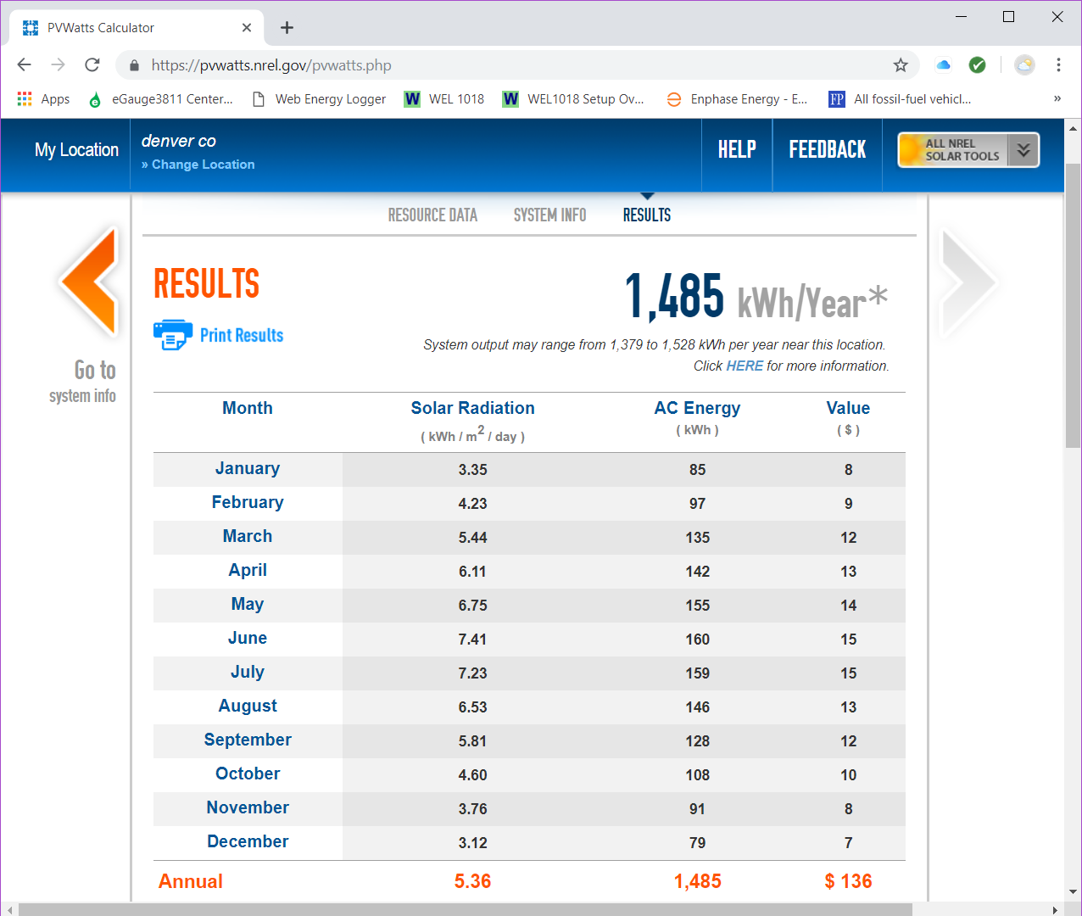Using information from the National Renewable Energy Laboratory (NREL) in Golden, CO (actually a computer model available to the public called PVWATTS. Go to <http://pvwatts.nrel.gov/pvwatts.php> ), you learn that a 1 kW rated system mounted on your south-facing roof in Denver, CO (at a 10 degree tilt) is expected to generate 1,485 kWh of power annually. (For this computer model, south-facing is 180 degrees azimuth, East facing is 90 degrees azimuth). Let’s now determine approximately how large a south-facing solar PV system must be to produce all of your own electrical power.

|  |  |  |  |
| --- | --- | --- | --- |
| (3.4) | Approximate Size of Solar System You Need  [Divide line (3.3) by 1485 kWh/kW (rated DC power) ]  **But what if:** you don’t have any south-facing roof? The PVWATT computer allows you to specify the orientation. E.g. East-facing (Azimuth = 90 degrees). | (3.3) / 1,485 = _______ kW | 72040/1485= **48.5 kW=** |

In this example, we would need a 48.5 KW solar PV system that faces south. The current Xcel regulations also limit your PV system production to no more than 120% of your last 12 months usage – even if you “plan” to use more in the future (e.g. even if you plan to charge an electric car next month).

## Estimate the Number of Solar PV Modules (Panels) Needed

Typical solar PV modules (often called panels) can produce 300 W (0.3 kW) to 350 W (0.35 kW) of electrical power per module. The efficiency of the modules continues to improve slowly over time. For this “ball Park” example, we will use 300 W modules; they require more available surface area than the 350 W modules.

|  |  |  |  |
| --- | --- | --- | --- |
| (3.5) | Approximate Number of Solar Modules/Panels Needed  [Divide line (3.4) by 0.3 kW / module] | (3.4) / 0.3 = ________ modules | 48.5/0.3 = **162**  Modules |

## Estimate How much Surface Area is Required to Install Your Solar PV System.

Each panel is about 18 ft2 in area. (A typical solar module measures about 3’ x 6’).

|  |  |  |  |
| --- | --- | --- | --- |
| (3.6) | Approximate Surface Area Needed for Your Solar System  [Multiply line (3.5) by 18.  **Example:** In this example case, we would need around 162 panels that will take around 3000 ft2 of roof area, in your back yard or in a local solar garden. | (3.5) x 18.0 = _______ft2 | 162 x 18 = **2,916 ft2** |
| Compare the amount of roof area you need to what is considered available by Google Sunroof (<https://www.google.com/get/sunroof#p=0>  ) | | | |

## Estimate Approximate Cost of Your Solar PV System.

How much can this solar system be expected to cost?

Using the recent installation at First Universalist as a benchmark, we can get a “Ball Park” estimate of the cost to install your solar PV system. We say “Ball Park” because every system will be slightly different depending on where and how the system is mounted. In the case of First Universalist, the majority of the modules were ballast mounted on a flat roof – probably the least expensive installation. As a result, the cost was just under $2.50 / Watt using a Pre-paid Power Purchase Agreement.

|  |  |  |  |
| --- | --- | --- | --- |
| (3.7) | Approximate Initial Cost of Your Solar System  [Multiply line (3.4) by 1000 W/ kW x $2.50]  Note: As a non-profit, your organization does not benefit directly from current Federal Tax Credits. However, a for-profit third party can benefit and pass along a portion of that rebate. This requires additional discussion. | (3.4) x 1000 x $2.50 = $__________ | 48.5 x 1,000 x $2.50 **= $ 121,250** |

They are several scenarios that make the investment even better financially.

1. There is a growing movement to impose a “price on carbon pollution.” If there a carbon burning fee becomes a reality, those who have invested in solar PV will benefit financially.
2. If Xcel takes less than 20 years to transition to 100% inexhaustible/renewable energy, those who invested early in solar PV will still have helped slow the rate of climate change.
3. You may be eligible for REC payments.

Your solar PV also avoided dumping more mercury and other heavy metals as well as NOx and fly ash into the atmosphere – as you know, these by-products of burning fossil fuel find their way into human and non-human beings through the food chain.