# 6. Life Cycle Cost Analysis (LCCA) & Revenue–Neutral Funding Model

C

onducting a Life Cycle Cost Analysis (LCCA) and constructing a Revenue-Neutral financing approach may be the most important role for the Green Team of an organization that wants to reduce their GHG emissions to zero.

The previous segments of this workshop assembled the essential information needed to conduct a life cycle cost analysis of a sustainable energy system that has zero GHG emissions and compare it to the life cycle cost of the current GHG emitting fossil fuel based system. The final step is to propose how to pay for a new energy system – preferably using a financing approach that does not change the organization’s operating budget.

The Green First Team found that if they could present a funding model to the Board/Vestry/Council for a new zero GHG emissions energy system that was “Revenue Neutral” (i.e. an approach that does not require a change in the organization’s budget), they could get the Board’s immediate attention. So, that funding approach became their goal. Any plan that increased the organization’s operating budget would make the approval path steeper to climb.

The proposed financial approach illustrates ONE path to zero GHG emissions. It is not the only path. However, a “Revenue Neutral” funding approach serves as a baseline Life Cycle Cost estimate for comparison with other clever funding approaches involving third parties (Power Purchase Agreements, Leases, PACE, Commercial Loans, etc.). The baseline also identifies the amount of sacrifice required by the congregation (if any).

## Basic Assumptions / Definitions.

### Life-cycle cost analysis (LCCA)76F76F[1]

is a tool to determine the most cost-effective option among different competing alternatives to purchase, own, operate, maintain and, finally, dispose of an object or process, when each is equally appropriate to be implemented on technical grounds.

### Life-cycle assessment (LCA, 77F77F[2] also known as life-cycle analysis, ecobalance, and cradle-to-grave analysis)

 is a technique to assess environmental impacts associated with all the stages of a product's life from raw material extraction through materials processing, manufacture, distribution, use, repair and maintenance, and disposal or recycling. Designers use this process to help critique their products. LCAs can help avoid a narrow outlook on environmental concerns by:

* Compiling an inventory of relevant energy and material inputs and environmental releases;
* Evaluating the potential impacts associated with identified inputs and releases;
* Interpreting the results to help make a more informed decision.[[2]](https://en.wikipedia.org/wiki/Life-cycle_assessment#cite_note-2)

A good example of a Life-Cycle Assessment is the work of Paul Epstein, et al. of the Harvard Medical Center.

"We estimate that the life cycle effects of coal and the waste stream generated are costing the U.S. public a third to over one-half of a trillion dollars annually. **Accounting for the damages conservatively doubles to triples the price of electricity from coal per kWh generated**, making wind, solar, and other forms of non-fossil fuel power generation, along with investments in efficiency and electricity conservation methods, economically competitive."

**"Life cycle analysis, examining all stages in using a resource, is central to the full cost accounting needed to guide public policy and private investment."**

“This work strives to derive monetary values for these externalities so that they can be used to inform policymaking."

“Our comprehensive review finds that the best estimate for the total economically quantifiable costs, based on a conservative weighting of many of the study findings,...to be close to **17.8¢ /kWh** ...the upper bounds of electricity generated from coal could add close to 26.89¢ /kWh....These and the more difficult to quantify externalities are borne by the general public.”[3]

A Life Cycle Cost Analysis is a useful (classical) financial tool when trying to make decisions about “capital equipment.”

**Capital Equipment**. Equipment used by an organization to carry out their mission. Any single asset which has an acquisition cost of $5,000 or more and a useful lifespan of more than one year, whether purchased outright, acquired through a lease or through donation.

**Asset.** Solar PV modules and HVAC equipment (furnaces, heat pumps, A/C units, etc.) would be considered as assets that have an estimated useful lifespan of 15-20 years.

A Life Cycle Cost Analysis identifies the total cost over the useful lifespan of the equipment. We assume the lifespan is 20 years for this example involving energy related equipment. The total cost captures the initial cost and the recurring or ongoing annual operational cost over the 20-year period.

|  |  |  |  |  |  |
| --- | --- | --- | --- | --- | --- |
|  | Initial Cost | Recurring / Ongoing Cost over 20 years | Ignored Social Costs (Externalities)  (Injustices) | Classical Total Cost | True4  Total Cost |
| **Fossil Fuel System**  (Xcel electric and natural gas) | Minimal1 | Significant | Significant to Extreme3 | Minimal + Significant | Significant to Extreme |
| Sustainable System  (Solar electric and Heat Pump heating and cooling) | Significant | Minimal2 | Zero To Minimal | Minimal + Significant | Significant |
| Notes:   1. First Universalist had 10 natural gas furnaces with external A/C units. Two old furnaces needed to be replaced. 2. Even if the new energy system generates 100% of the church energy needs, there is a monthly Xcel “Demand” or “Time of Use” charge because we remain in the grid and use Xcel as our “energy bank.” 3. Extreme refers to ignored health issues as well as the climate crisis and existential threat of a sixth mass extinction 4. “True” cost is the ethical/moral/faith-based assessment that does not ignore social costs. | | | | | |

Installing a sustainable energy system requires a significant investment in new capital equipment; so there will be a significant **initial cost** for the new system.

Both the existing and proposed energy systems will have **operating costs** generally described as annual costs; the operating cost for the fossil fuel system is significant. There is a monthly charge for gas and electric. Typically, the existing equipment is well into its operational life and will require replacement within the next 20-years. The replacement cost must be included (often as an annual average replacement cost when multiple units are involved).

When the initial and operating costs are added up over 20 years, the renewable energy system life-cycle cost will be less. There will be a financial gain in transitioning to renewable energy.

## How do you know there will be a financial gain?

***“The best way to predict your future is to create it.”***

***…*** *“Inventing the Future” by Dennis Gabor, 1963  
(also attributed to Abraham Lincoln by many)*

There will be a financial gain because the ‘Green Team’ can develop a financing approach that creates the gain.

The detailed **Case Study** describes the technique First Universalist used to construct a funding approach that:

1) Does not require the church to pay an upfront cost, and

2) Maintains the same annual utility costs as the current fossil fuel system, and

3) Results in a financial gain over 20 years, and most importantly

4) Allows the church to stop contributing to global warming now - not 5 or 10 years from now when the existing fossil fuel equipment wears out.

At this point, there is enough information to construct a 20-year life cycle cost analysis (LCCA). A simple spreadsheet can be used to display the results of the LCCA.

## Revenue-Neutral Funding Plan Development

A relatively simple financial spreadsheet model similar to that shown in Figure 1 was used to develop a “Revenue Neutral” funding plan.

The final model that was found to be workable for the Green First Team grew out of ideas developed earlier by Christ the Servant Lutheran in Louisville, CO, and St. John’s Episcopal Church, Boulder, CO. After searching for the better part of a year for a third party investor to fund their new ‘energy system’ (that included both solar and geothermal equipment,) without success, the Green First Team finally gave up. Using the self-funding examples of the Lutheran and Episcopal congregations, the Green First team considered using an LLC made up of church members. It turned out that the LLC approach did not work as well at First Universalist because the congregational demographics did not identify enough members with ‘passive income’ for the amount of capital they needed to raise. Nevertheless, the idea of self-funding was still a good idea, and the LLC morphed into a Partnership of church members as explained in this detailed **Case Study**. It is fair to say that First Universalist would not have found their path without the new ways of thinking opened up by Christ the Servant Lutheran and St. John’s Episcopal.

Essential steps in designing a “Revenue Neutral” funding plan include:

1. Analyze the cost of operating the existing fossil-fuel-based energy system.
   1. Include the monthly bills for the past year
   2. Include all maintenance and replacement costs for the past year. For greater accuracy, you can look at the age and service life of the existing equipment (furnaces and A/C units) and determine the forward-looking replacement costs and use that instead.
   3. Include a 3-4% escalation in the hydrocarbon-based energy costs.

This cost becomes the baseline annual operating cost of the existing hydrocarbon-based energy system.

1. Estimate the size of the sustainable energy system. Knowing the size of the solar system and heat pump system required, it is possible to estimate the installation and operating costs.
2. Assume it is possible to solicit low interest (e.g., 1.5% interest) member loans from the congregation. Envision the money in the church budget earmarked for utility expenses being used differently. Envision that same amount of money is used instead to finance a new sustainable energy system, specifically to service a loan repayment schedule. Determine the size of a 1.5% loan that can be repaid using the existing “utility” budget. Assume a 10 to 15-year term for the member loans.
3. Subtract the loan value from the total cost of the energy system to define the size of the member donations and public grants required to create a Revenue Neutral funding model.

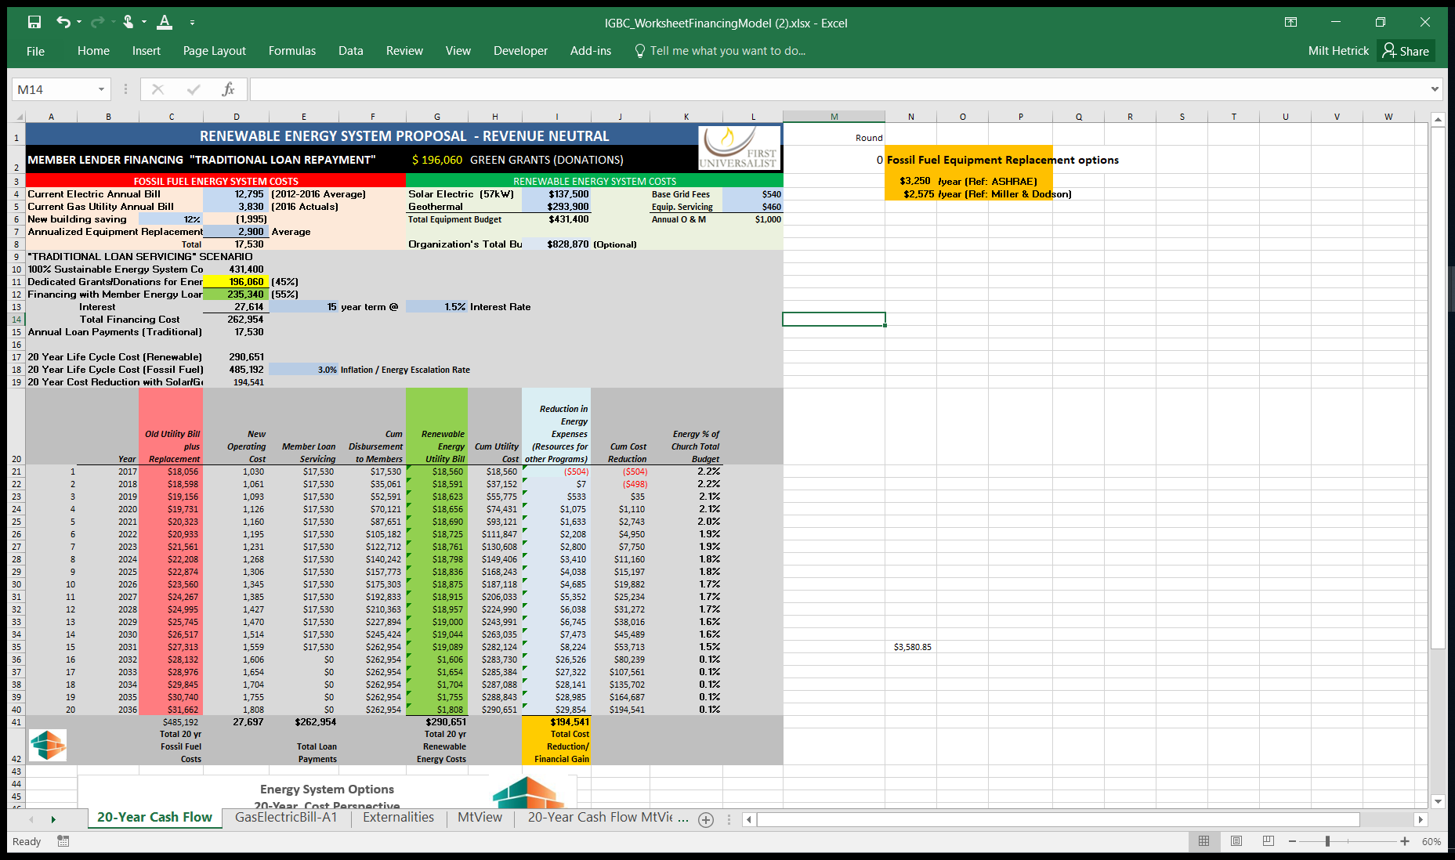

Figure 1 A 20 Year Life Cycle Cost Assessment Used for the First Universalist Sustainable Energy System Project.

The spreadsheet model shown in Figure 1 can be helpful. It will perform all these calculations when you input the basic costs.

|  |  |
| --- | --- |
| **Revenue Neutral Funding Model** | |
| <http://coloradointerfaithgreenbuilding.org/Solar-GeoFundingModelA.pdf> | C:\Users\mahet\AppData\Local\Microsoft\Windows\INetCache\Content.MSO\DD662B3F.tmp |
| <http://coloradointerfaithgreenbuilding.org/Solar-GeoFundingModelA.xlsx> | 5D1E36AD |

This funding approach is offered as an example: it may not work in your situation. It does serve as a baseline that has a good probability of being approved because “it doesn’t cost the church anything” to make the transition to renewable energy. There is no change in the church budget – there is no additional mortgage – the lenders do want a promissory note that in effect says, the church will continue to pay the utility bills – at least until the loans are paid off.



Figure 2 Comparison of Annual Expenses for operating a Fossil Fuel Energy System (RED) vs. a Renewable Energy System (GREEN) using a 20-year Perspective.

## Using the Model

### Input Current Utility Expenses (into the light blue cells)

Cell D4: insert the Current Annual Electric Bill (Line 3.1 of the Section 3 worksheet) – *in this example $12,795 / year.*Cell D5: insert the Current Annual Gas Bill (Line 4.1 of the Section 4 worksheet) – *in this example $3830 / year.*Cell D6: If there is any plan to include energy conservation measures, estimate the expected reduction in the percent of the total utility bill – *in this example 5% or $830 / year.*   
Cell D7: Estimate the average annual cost for the replacement of existing equipment. Hint: For a 20-year assessment, you can assume the entire set of existing equipment will have to be replaced.

### Input the Estimated Costs of the New Equipment

Cell I4: insert cost of the solar PV system - *in this example $137,500.*   
Cell I5: input the cost of the Geothermal system - *in this example $293,900.*   
Cell L4: This is a complicated parameter and hard to estimate at this stage of an idea. It can range from several hundred dollars to several thousand annually depending on the specific situation. If your pattern of power usage never exceeds 25 kW for any 15 minutes, this will be several hundred dollars. If your power usage ever exceeds 25 kW for 15 minutes or longer during a billing cycle, there could be a “demand” charge of several thousand dollars. First Universalist has a usage profile that has occasional peak demands above 25 kW and as a result, is paying a demand charge equivalent to $3600 / year. (There are ways to minimize this Fee that are beyond the scope of this estimating workshop) - *in this example $540 / year was assumed.*

Cell L5: It is wise to have a service agreement to help maintain the energy system. Both the Solar Electric and Geothermal systems can be monitored remotely using the internet. Both systems should have 10-20 year warranties but do budget several hundred dollars annually - *in this example $460 / year was assumed.*

Cell L6: The sum total Operating and Maintenance expensions are estimated to be $1000 /year.



It is now time to explore ways to raise the capital required to purchase the new equipment. Generally, it is easier to take out a loan than solicit grants/donations. So the spreadsheet model maximizes the size of a loan that can be serviced by the available revenue budgeted for utilities.

After providing this necessary information, the model calculates the amount of money that can be borrowed and repaid by diverting the current utility expenses (no longer relevant for the proposed renewable energy system) to repay a loan.





To use this approach, the user must set some boundaries for a loan. Namely, the interest rate and period of the loan must be assumed/specified. *First Universalist found member donors willing to loan the church money at an interest rate as low as 1.5% for a period as long as 10-15 years.*

This loan information is input into the following cells:

Cell E13: e.g., assume 15-year term for a loan  
Cell G13: Assume a 1.5% interest rate

Next, assume an energy escalation rate expected over the next 20 years. The escalation rate will determine the repayment schedule. A higher repayment rate will pay off the loan sooner. This energy escalation rate does not affect the initial cost of the new energy system; it does affect the annual operating cost of the fossil fuel system.

Cell E18: Assume 3% escalation represents what to expect in the future unless you have better historical data.

In this case, the maximum loan amount that can be serviced with the existing utility budget is around $235,000 as indicated in the green Cell D12. The remainder of the capital that will have to be raised by grants and donations is $196,000 as shown in the yellow Cell D13.

First Universalist was able to raise $200,000 in donations and could have raised $300,000 in low-interest loans but was limited to using only $235,000 by the Board of Trustees.

## Discussion of Results

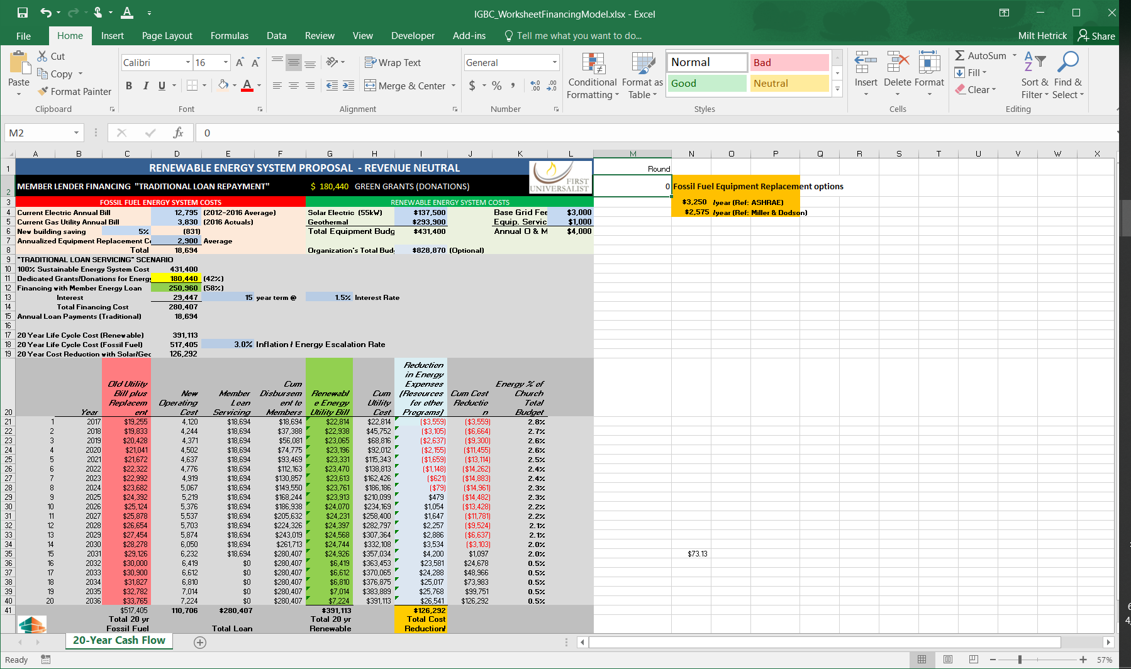



Rows 21 through 40 provide the 20-year cash flow information. Column C indicated in red, defines the expected annual expenses using the existing fossil fuel-based energy system. At the end of 20 years, the church was expecting to have a stack of paid utility bills totaling $485,192 if it continued to burn fossil fuel as an energy source.

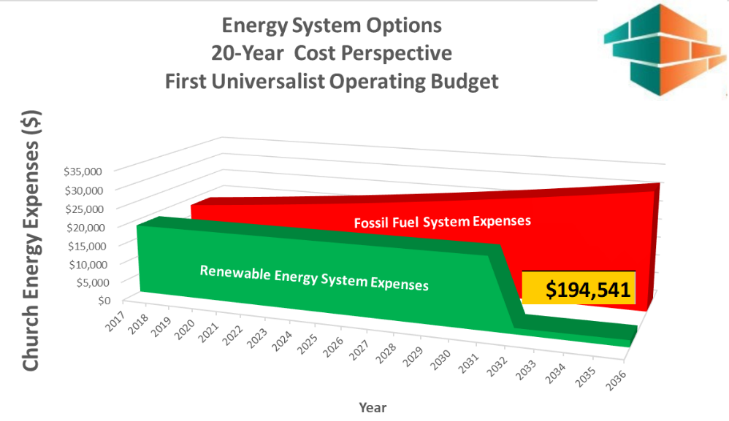Column G (indicated in green) defines the utility bill with a new sustainable energy system. In this example, the new utility bill is LESS than the fossil fuel system (except the first year). After 20 years, the church outlay is $290,651 (G41). Notice also that after 15 years, the “utility expenses” drop to less than $2000 (G36) because the loans will be paid off by then.

As indicated, a sustainable renewable energy system is expected to provide a financial gain of nearly $195,000.(I41)

# Appendix A But What about Energy Storage?

Because of the nature of solar PV, the amount of energy available varies over a day and the course of a year. There are 2 million documented species alive today that have evolved to accommodate these seemingly “inconvenient” ground rules of life. Humans still have a lot to learn from their distant cousins (the non-human living systems) that co-habit our planet. Our autotroph cousins that look directly to Sun for the energy they need to live (e.g., a tree) harvest sunlight during the day, store some energy for growth during the night and in the winter when there is less sunlight available. The Tesla Corporation (and SolarCity a close associate) announced earlier in the year that they planned to provide a new product for homeowners – an affordable electrical energy storage system that fits in a garage. This battery pack uses the lithium battery technology developed for electric cars and repackages the cells to fit along the wall of a typical garage. A 7kWh battery was priced at $3000 and a 10 kWh battery at $3500. PowerWall 2 stores 13.5 kWh and costs $6-7000.

Energy storage for power generated from wind and solar is a challenging but not insurmountable problem. There are several dozen “Storage Solutions” currently being evaluated. The U.S. Department is researching a half dozen promising solutions. Wikipedia lists a broader range of Energy Storage possibilities. NREL and Germany have developed and are testing prototype hydrogen fuel-cell powered electric cars. Pumping water uphill to storage reservoirs, compressing gas and using excess electricity to electrolyze water and generate hydrogen for long term storage are just a few of the current Energy Storage options being evaluated seriously. Australia has started marketing a “flow battery” alternative to Lithium Ion batteries. So it is an exciting future for folks who like to solve problems. Learning to live sustainably is a solvable problem.

# Appendix B How Geothermal Heat Pumps Work

Using a heat exchanger, a geothermal heat pump can move heat from one space to another. In summer, the geothermal heat pump extracts heat from a building and transfers it to the ground for cooling. In winter, the geothermal heat pump takes natural heat from the ground beneath the north parking lot and transfers it into the building for heating. Although heat pump options vary somewhat, typically one unit of energy (electrical) can exchange 3-5 units of thermal energy between the Earth and a building. Although the homeowner buys or provides the 1 unit of power from rooftop solar, the owner is not charged for the 3-5 units of thermal energy transferred from the house in the summer to cool it or the 3-5 units of ground heat into the house to warm it.

Although the technology is as old as refrigerators, ground source heat pumps have not thrived, because our current broken economic system riddled with externalities indicates sustainable geothermal heat pumps are more expensive than unsustainable fossil fuel burning furnaces.

Installing a geothermal heat pump system can be the most cost-effective and energy efficient home heating and cooling option. Geothermal heat pumps are a particularly good option if you are building a new home or planning a major renovation to an existing home by re-placing, for example, an HVAC system. For more information please see the following resources:   
 **DOE Energy Savers: Geothermal Heat Pumps, www.energysavers.gov/ geothermal_heat_pumps   
 Energy 101: Geothermal Heat Pumps, www.eere.energy.gov/multimedia/ vid-eo_geothermal_heat_pumps.html**

# Appendix C Externalities

Today we know that our economic system is broken. It allows many types of producers (including 'for-profit' Utility Corporations) to ignore/externalize the social costs of their products in the market price. As a result the free market is not properly informed of the true cost / total cost of that product. Attempting to identify & internalize these ignored costs is a good place to start. In the detailed study by Epstein et al. cited below, there are a dozen ignored cost that are identified and monetized specifically for coal-generated electricity:

• Land disturbance

• Methane emissions from mines

• Carcinogens (mostly to water from waste)

• Public health burden of communities in Appalachia

• Fatalities in the public due to coal transport

• Emissions of air pollutants from combustion

• Lost productivity from mercury emissions

• Excess mental retardation cases from mercury emissions

• Excess cardiovascular disease from mercury emissions

• Climate damage from combustion emissions of CO2 and N2O

• Climate damages from combustion emissions of black carbon

REFERENCE: "**Full cost accounting for the life cycle of coal**" by Paul R. Epstein, Jonathan J. Buonocore, Kevin Eckerle, Michael Hendryx, Benjamin M. Stout III, Richard Heinberg, Richard W. Clapp, Beverly May, Nancy L. Reinhart, Melissa M. Ahern, Samir K. Doshi, and Leslie Glustrom, Harvard Medical Center for Health and the Global Environment, ANNALS OF THE NEW YORK ACADEMY OF SCIENCES Issue: Ecological Economics Reviews

"We estimate that the life cycle effects of coal and the waste stream generated are costing the U.S. public a third to over one-half of a trillion dollars annually. **Accounting for the damages conservatively doubles to triples the price of electricity from coal per kWh generated**, making wind, solar, and other forms of nonfossil fuel power generation, along with investments in efficiency and electricity conservation methods, economically competitive."

"Life cycle analysis, examining all stages in using a resource, is central to the full cost accounting needed to guide public policy and private investment.”

"To rigorously examine these different damage endpoints, we examined the many stages in the life cycle of coal, using a framework of environmental externalities, or “hidden costs.” Externalities occur when the activity of one agent affects the well-being of another agent outside of any market mechanism—these are often not taken into account in decision-making, and when they are not accounted for, they can distort the decision-making process and reduce the welfare of society.

This work strives to derive monetary values for these externalities so that they can be used to inform policy making."

“Our comprehensive review finds that the best estimate for the total economically quantifiable costs, based on a conservative weighting of many of the study findings,...to be close to 17.8¢ /kWh ...the upper bounds of electricity generated from coal could add close to 26.89¢ /kWh....These and the more difficult to quantify externalities are borne by the general public.

# Appendix D Life Cycle Assessment

## The Europeans are far ahead of the U.S. in terms of addressing sustainable living and sustainable products. For the past decade they have extending an assessment tool called GaBi to assist them in designing and manufacturing sustainable products as well as creating sustainable enterprises. See: <http://www.gabi-software.com/overview/product-sustainability-performance/>

|  |
| --- |
| Product Sustainability Performance<https://youtu.be/XmFmXyChufs>Every day over 2,500 leading businesses rely on GaBi Software to drive their product sustainabilityGaBi is the most trusted product sustainability solution for Life Cycle Assessment with over 10,000 users including Fortune 500 companies, leading industry associations and innovative SMEs.GaBi provides the answers to your most pressing product sustainability questions:R&D, Product Development & Design How can we develop a sustainable product portfolio to build competitive advantage and increase revenues? Sustainability/Environment Department How can we build a product sustainability strategy and meet our targets? Marketing & Communications How can we differentiate our products with verifiable sustainability credentials to drive customer preference? Operations How can we use resources more efficiently and optimize processes throughout the value chain to reduce cost? Supply Chain How can we identify supply-chain hotspots including materials and processes of concern to mitigate risk? |

|  |
| --- |
| What is GaBi Software?GaBi is the next generation product sustainability solution with a powerful Life Cycle Assessment engine to support the following business applications:Life Cycle Assessment  * **Design for Environment:** developing products that meet environmental regulations * **Eco-efficiency:** reducing material, energy and resource use * **Eco-design:** developing products with smaller environmental footprints such as fewer GHG emissions, reduced water consumption and waste * **Efficient value chains:** enhancing efficiency of value chains e.g. R&D, design, production, suppliers, distribution  Life Cycle Costing  * **Cost reduction:**designing and optimizing products and processes for cost reduction  Life Cycle Reporting  * **Sustainable Product Marketing:** product sustainability labels & claims, Environmental Product Declarations (EPDs) * **Sustainability Reporting:** environmental communication & product sustainability reporting * **LCA knowledge sharing:** reporting and analysis for internal departments, management and supply chain  Life Cycle Working Environment  * **Responsible manufacturing:** developing manufacturing process that address social responsibilities |

|  |
| --- |
| EF Database v2.0 EF Database (Environmental Footprint Database) v2.0 Environmental Footprint Database v2.0 The Environmental Footprint (EF) database is designed to support the implementation of Product Environmental Footprint (PEF) and Organisation Environmental Footprint (OEF) studies. It contains the official secondary EF-compliant life cycle inventory datasets and the compatible EF impact assessment methods.  The Environmental Footprint database is part of the [European Commission’s Single Market for Green Products Initiative](http://ec.europa.eu/environment/eussd/smgp/).EF Database v2.0 Project Partners http://www.gabi-software.com/typo3temp/pics/2e2a4da0db.png  **Facilitated by:** European Commission  **Developed by:** Blonk Consultants, CEPE, Cycleco, ecoinvent, FEFAC, FEVE, maki Consulting. PRé Sustainability, Quantis, RDC, thinkstep  For users of any LCA software, which is able to deal with ILCD format and the special requirements of the EF 2.0 database, there are two options to gain access to the EF data: Cost Free Usage For official PEFCR/OEFSR-based studies  Complete EF v2.0 Database  [Read more ...](http://www.gabi-software.com/databases/ef-database-v20/cost-free-usage-of-ef-database/) |

# Appendix E 1.5% Interest Loan Discussion within the Green Team

Using a combination of donations and low interest (i.e. 1.5% interest) member loans seemed to be emerging as a viable financing approach for First Universalist.

***Discussion.*** The low-interest member loan approach was aligned with several ideas advocated by the members of the congregation. For example:

* Income inequality and wealth inequality are already crippling this country. Avoid feeding Wall Street where possible.
* Avoid commercial usury rates where possible. Look for socially responsible investors who want to “put their money to good use” and invest in efforts that consistent with their values.
* Look for member investors & lenders who are not focused on “making money” but instead “want to promote a good cause that represents their values.”
* Try to keep wealth within the local community where it provides local jobs. Better yet, keep the entire financial gain within the church community. If you have to pay any usury fees, pay it to yourself – to your church members.

An informal poll by the Green First team indicated that members were “tapped out” as far as making further donations to the church. That same poll indicated some members would be willing to “loan” money to the church if they at least got back their principle.

Three Green First team members had been involved for several months over the 2015-2016 winter trying to figure out how to make a third party LLC funding model work for their congregation. This LLC approach was patterned after a model developed locally by St. John’s Episcopal Church in Boulder. The St. John’s congregation created an LLC to fund their rooftop solar system that would provide 30% of electrical power requirements. The Green First Team had set a goal to fund a 100% solar system plus 100% heating & cooling system. Including the geothermal heating and cooling system made the traditional economics less attractive, but the Green First Team was insisting on an “all in” system with zero GHG emissions now.

As they struggled to find an LLC funding approach that would work for First Universalist, the team became aware of how onerous high-interest rate loans can be. The team could only make an LLC model work if their “investors” were willing to accept a minimal return on their investment (ROI). [Minimal means zero to 1%]

As recalled by one Green First team member:

“After the Science Presentation, we put together a new cash flow model that included a donation option, a commercial loan option, and a member loan (1.5%) option. After trying various arrangements of donations/loans, we finally stumbled on a possible solution that seemed to work. It involved donations for about 40-50% of the capital required to buy the new energy system and the remainder as member loans at 1.5% interest rate. The result was a monthly repayment plan comparable to the current monthly budget for gas & electric. ew changes were made, and a new spreadsheet funding model was created to define the cash flow over the next 20 years. The funding model confirmed there would be a significant financial gain by the church over a 20-year time frame and the plan was ‘revenue neutral’ meaning it did not increase the church operating budget.”

1. See: <https://en.wikipedia.org/wiki/Life-cycle_cost_analysis>, <https://www.nist.gov/customcf/get_pdf.cfm?pub_id=907459>
2. See: <https://en.wikipedia.org/wiki/Life-cycle_assessment> or  ["Defining Life Cycle Assessment (LCA)."](http://www.gdrc.org/uem/lca/lca-define.html) US Environmental Protection Agency. 17 October 2010. [ <http://www.gdrc.org/uem/lca/lca-define.html> ]
3. "**Full cost accounting for the life cycle of coal**" by Paul R. Epstein, Jonathan J. Buonocore, Kevin Eckerle, Michael Hendryx, Benjamin M. Stout III, Richard Heinberg, Richard W. Clapp, Beverly May, Nancy L. Reinhart, Melissa M. Ahern, Samir K. Doshi, and Leslie Glustrom, Harvard Medical Center for Health and the Global Environment, ANNALS OF THE NEW YORK ACADEMY OF SCIENCES Issue: Ecological Economics Reviews